PHYSICS 202 … Practice Problems

Electrostatics … Part B

1. Electric Point Charge in an Electric Field: For each of the following situations calculate the force exerted on the charge by the external field.
   1. 3.50 x 10–5 C point charge in a 215 N/C field directed to the right.
   2. 6.74 x 10–7 C point charge in a 5.15 x 104 N/C field directed upward.
   3. –5.55 nC point charge in a 3.35 x 105 N/C field directed to the right.
   4. –2.50 µC point charge in an electric field of 5.69 N/C $\hat{i}$– 4.24 N/C $\hat{j}$.

1. Coulomb Force: For each of the situations calculate the magnitude of the coulomb force between the point charges.
   1. A 5.50 x 10–5 C point charge and a 7.30 x 10–5 C point charge that are 3.22 x 10–4 m apart.
   2. A 6.25 µC point charge and a –4.50 µC point charge separated by 4.39 mm.
   3. Two identical 245 nC point charges separated by 5.300 x 10–5 m.
   4. Two electrons that are 25.0 nm apart.

1. Electric Dipoles: For each of the situations calculate the magnitude of the electric dipole moment.
   1. A 3.00 nC charge and a –3.00 nC charge separated by 0.00420 mm.
   2. A charge of e and a charge of –e separated by 6.50 µm.
   3. A charge of 3e and a charge of –3e separated by 3.40 x 10–8 m.

1. Charge Distributions: The diagram below shows a distribution of four electric point charges.

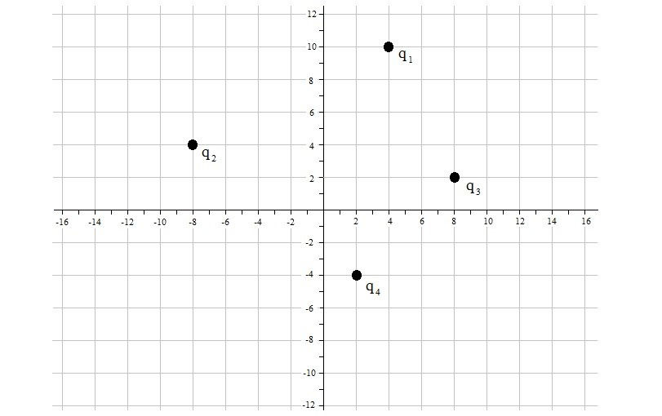

The x and y-axes are indicated in units of centimeters (accurate to 3 sig. figs.) and the charges are:

q1 = 5.70 nC; q2 = 8.50 nC; q3 = –3.70 nC; q4 = –6.40 nC.

* 1. What is the net electric field at the origin?
  2. What is the magnitude of the net electric field at the origin?
  3. What is the force on q1 due to q4?
  4. What is the force on q4 due to q2?

1. Electric Dipole in an External Electric Field: The diagram below shows an electric dipole. The coordinate system (x to the right and y toward the top of the paper) is shown with axes in units of micrometers.

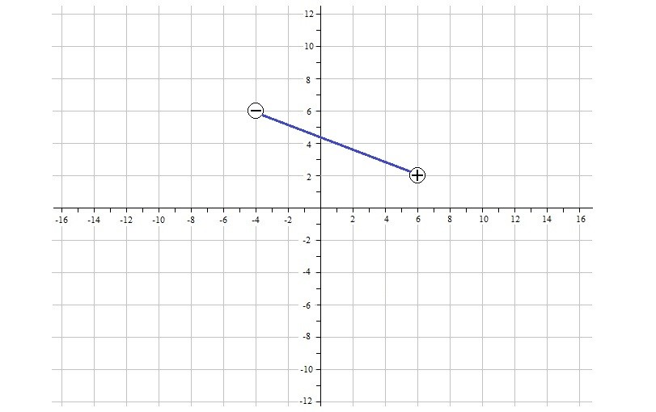

* 1. For the following problems use q = 3.60 x 10–4 C.
     1. What is the electric dipole moment?
     2. If there is an external electric field of 7.25 x 104 N/C , what is the torque on the electric dipole?
     3. If there is an external electric field of 7.25 x 104 N/C , what is the potential energy of the electric dipole?

* 1. For the following problems use q = 22.5 nC.
     1. What is the electric dipole moment?
     2. If there is an external electric field of 240 N/C $\hat{j}$– 320 N/C $\hat{k}$, what is the torque on the electric dipole?
     3. If there is an external electric field of 240 N/C $\hat{j}$– 320 N/C $\hat{k}$, what is the potential energy of the electric dipole?